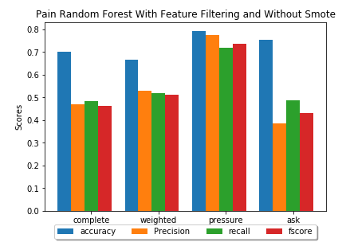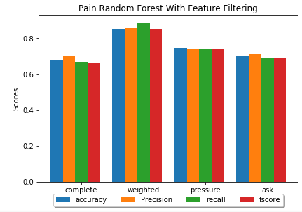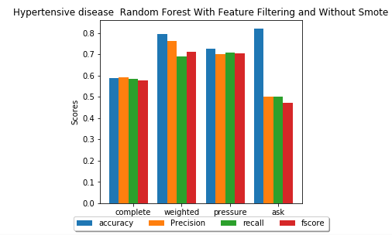

Figure 1 Pain RF with Feature Filtering and Without SMOTENC

Figure 2 Pain RF with Feature Filtering and SMOTENC

Figure 3 Hypertensive disease RF with Feature Filtering and without SMOTENC

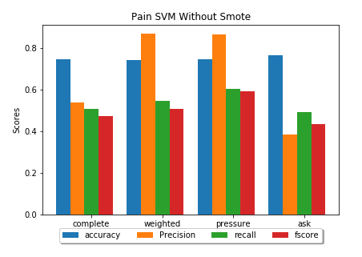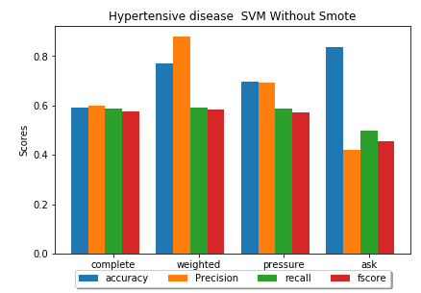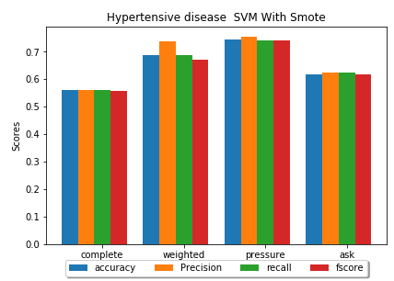

Figure 4 Pain SVM without SMOTENC

Figure 5 Hypertensive disease SVM without SMOTENC

Figure 6 Hypertensive disease SVM with SMOTENC

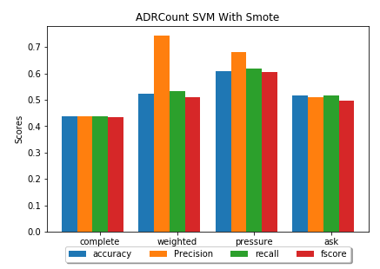

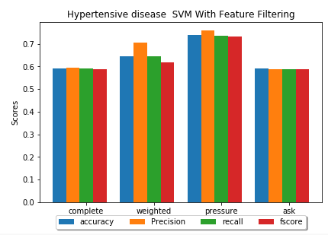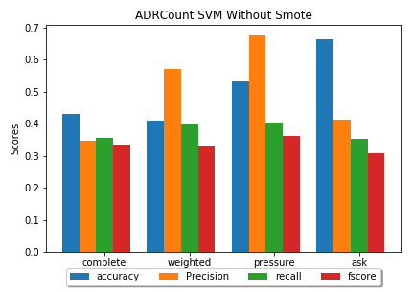

Figure 7 Hypertensive disease SVM with Feature Filtering

Figure 8 ADR Count Without SMOTENC

Figure 9 ADR Count with SMOTENC

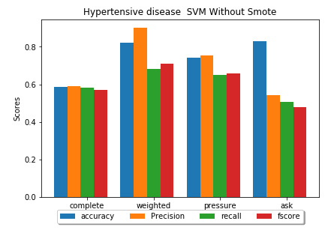

Figure 10 Hypertensive disease SVM with Feature Filtering without SMOTENC

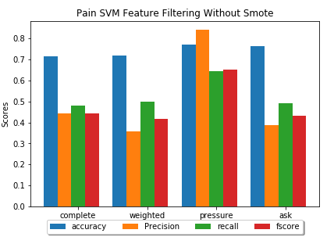

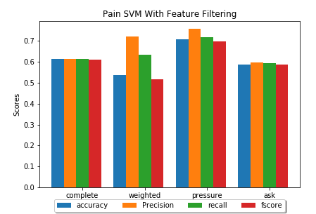

Figure 11 Pain SVM with Feature Filtering and SMOTENC

Figure 12 Pain SVM with Feature Filtering Without SMOTENC

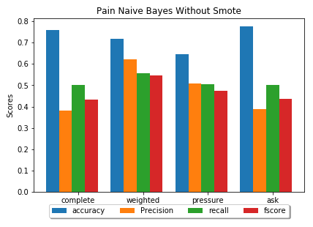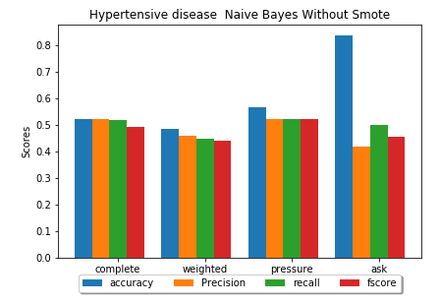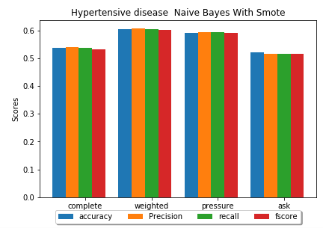

Figure 13 Pain NB Without Smote

Figure 15 Hypertensive Disease NB

Figure 14 Hypertensive Disease NB without SMOTENC

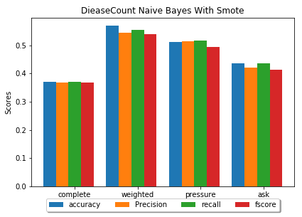

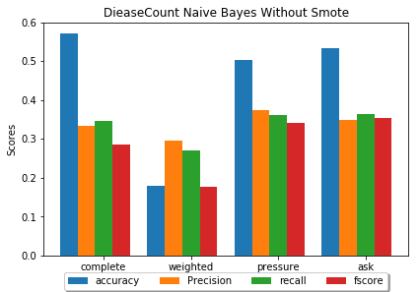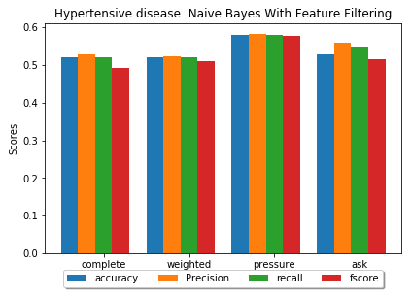

Figure 16 Hypertensive Disease NB with Feature Filtering

Figure 17 Disease Count NB without SMOTENC

Figure 18 Disease Count NB

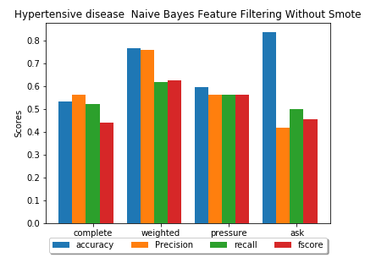

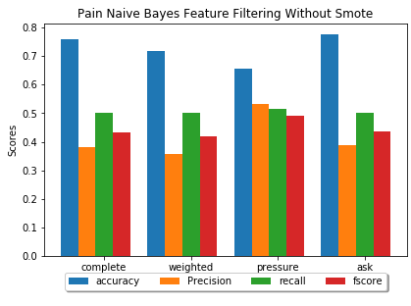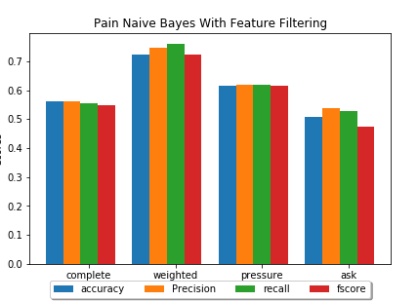

Figure 19 Pain NB with Feature Filtering without SMOTENC

Figure 20 Pain NB with Feature Filtering

Figure 21 Hypertensive Disease NB with Feature Filtering without SMOTENC

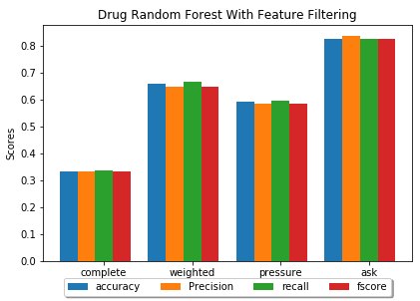

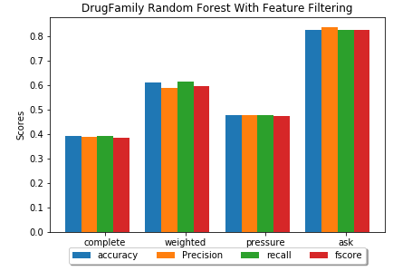

Figure 22 Drug Family predictions random Forest with feature filtering

Figure 23 Drug Predictions Random Forest with Filtering

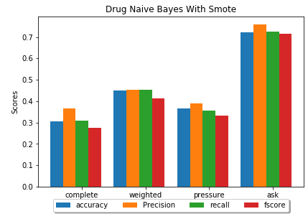

Figure 24 Drug Predictions with Naive Bayes

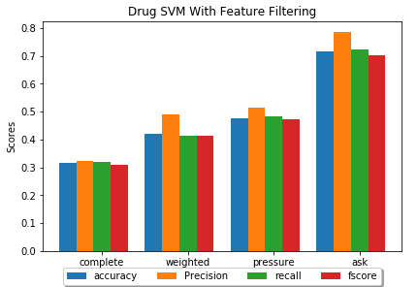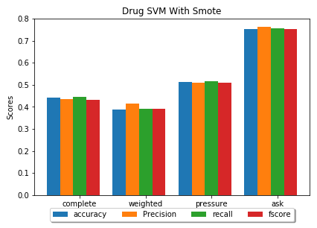

Figure 25 Drug prediction with SVM and Feature Filtering

Figure 26 Drug Predictions SVM

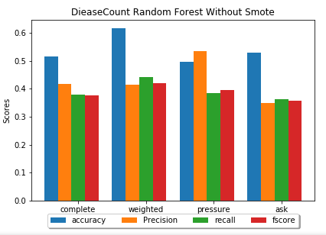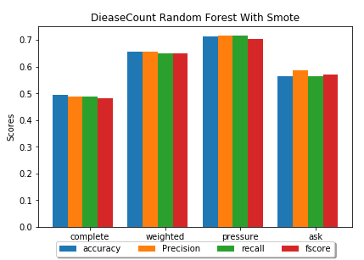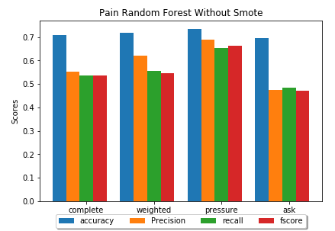

Figure 27 Disease Count RF with SMOTENC

Figure 28 RF Pain without SMOTENC

Figure 29 Disease Count RF without SMOTENC